

NAME: **NDETI AUGASTINE MULU**

ADM NO: **CSC/003/2017**

SCHOOL: **SCHOOL OF SCIENCE, TECHNOLOGY AND ENGINEERING**

COURSE CODE: **COM 423**

COURSE TITLE: **COMPUTER SCIENCE PROJECT II**

EMAIL: **AUGASTINENDETI@GMAIL.COM**

TASK: **PROJECT PROPOSAL**

**PROJECT TITLE: CHATBOT SYSTEM**

**ABSTRACT**

A chatbot is a computer program designed to simulate human conversation. The chatbot system replies to you instantly according to your queries, because as a programmer, I have inserted thousands of inputs, replies or queries into the database, that can be asked by the user.

**Contents of the Proposal**

INTRODUCTION ………………………………………………………………….… 1

LITERATURE REVIEW…………………………………………………………….… 2

METHODOLOGY............……………………………………………………………......3

CONCLUSI0N……………………………………………………………………………4

REFERENCES....................................................................................................................5

**CHAPTER 1. INTRODUCTION**

In the project of a ‘Simple Chatbot using PHP’, on the webpage, there will be a chat form, with an input field and a button labeled as "send" for typing a message and sending it to the bot. The system will use AI (Artificial Intelligence) algorithms in order to give the user appropriate answers. When you ask something to the bot, and that query exists in the database, then the bot shall reply a message according to your query instantly, but if your query has not matched any response to the database queries, then the bot replies a message labeled as "Sorry I’m unable to understand you!". The main objective of this project is to ensure that each and every person can connect with an organisation remotely. Some of the other objectives are listed below:

**-**Helping users stay updated on institutions or organisational activities.

**-**Allowing users to make enquiries at any given point of time, 24/7, as per their thoughts, without having to get to the institution or organisation.

**-**This System can be used as fast discussion board, for quicker responses.

.

**CHAPTER 2: LITERATURE REVIEW**

Chatbots can be grouped into four categories based on where it is integrated, namely service chatbots, commercial chatterbots, Chatbots for entertainment and advisory chatbots. Service chatbots provides facilities to the customers as the Logistic organization responds to a question about deliveries and copies of documents through messaging channel. Commercial chatbots are developed to purchase for customers. The Entertainment chatterbots are aimed at engaging the users with favorite sports, movies, music and the events that the customers enjoy. Advisory chatbots provide recommendations on services and offer maintenance goods. This type of advisory chatbots can converse with the customers to offer support and advice tips whenever it is needed. Applications can be categorized into Task-oriented chatbots, that aims to help and guide customers or the chatters to do some works and also have a short conversation and Non-Task oriented chatterbots, which is simply to have a conversation with customers for entertainment

The Chatbot system will help reduce the work load in institutions, to make processes easy and to give the desired functionality ingesting of time during the keeping the records of organizational or institutional processing procedures. The aim of this project is to develop a user-questions Evaluation mechanism, through using Chatbot, which is used to access the new innovative items through the application of features which reduces the complexity

It helps in current all works relative to College. It will reduce the cost of collecting the management & collection of information procedure will go on smoothly. The present project has been developed to meet the aspirations indicated in the modern age, hence interesting.

For future enhancement, I may add much new functionality to the Chatbot System. We want to add more chats-responses and blog facility. In short I want to give power to the system, to be at levels with what other social networking sites have. At the same time, this chatbot system is used to overcome the entire problem which web users are facing currently in some organizations or institutions, and making complete atomization of manual system to computerized system.

**CHAPTER** 3. **METHODOLOGY:**

**Languages Used-**

For Developing this project, following web technologies are used: -

-HTML-Developing application structure.

-CSS-For designing and styling the application Structure.

-PHP-For creating connection with database & executing query.

-MySQL-Storing messages & username in database.

**Software Used-**

-Software’s used for implementing web application on server are listed below: -

-Xampp control Panel-Starting the services for implementation.

-Apache-Creating a dummy server on web browser.

-MySQL-Storing the values from the web application.

**Scope of the System**

“Software scope describes the data and control to be processed, function, performance, user management, access control management”

**➢ Data and Control**

The input data to the system will be customer detail, as well as

document detail for order. The output data will be different reports and reports usable in order and inquiry analysis. With the help of various reports, easy to make any needed decision.

**➢ Functions**

Basic functions of the system authenticate the user and user inputs document details, customer details and inquiry details as needed. It processes the input data to make the output information presented as

reports.

**➢ Performance**

The performance of the system requires the project to take low resources from Server and present more information in smallest memory utilization.

**➢ User Management**

Each user should have its own password to log in to the system and based on the rolls and rights allocated to the user by the administrator of the system, user will be allowed to open the different forms and perform required operations.

**Project Plan & Scheduling**

The waterfall model is a popular version of the systems development life cycle model for software engineering. Often considered the classic approach to the systems development life cycle, the waterfall model describes a development method that is linear and sequential. Waterfall development has distinct goals for each phase of development. Imagine a waterfall on the cliff of a steep mountain. Once the water has flowed over the edge of the cliff and has begun its journey down the side of the mountain, it cannot turn back. It is the same with waterfall development. Once a phase of development is completed, the development proceeds to the next phase and there is no turning back. The advantage of waterfall development is that it allows for departmentalization and managerial control. A schedule can be set with deadlines for each stage of development and a product can proceed through the development process like a car in a carwash, and theoretically, be delivered on time. Development moves from concept, through design, implementation, testing, installation, troubleshooting, and ends up at operation and maintenance. Each phase of development proceeds in strict order, without any overlapping or iterative steps.

The disadvantage of waterfall development is that it does not allow for much reflection or revision. Once an application is in the testing stage, it is very difficult to go back and change something that was not well thought out in the concept stage. This is the classical system development model. It consists of discontinuous phases:

1. Concept

2. Requirements

3. Architectural design

4. Detailed design

5. Coding and development

6. Testing and implementation

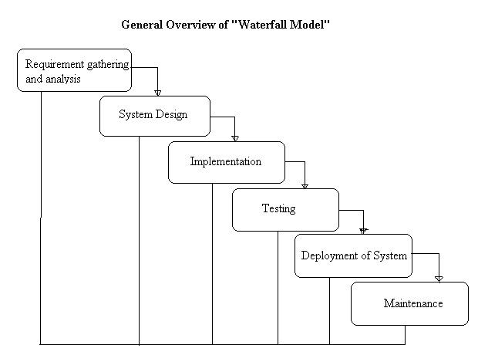

**Strengths**

Minimizes planning overhead since it can be done up front.

Structure minimizes wasted effort, so it works well for technically weak or inexperienced staff.

**Weaknesses**

Inflexible

Only the final phase produces a non-documentation deliverable.

Backing up to address mistakes is difficult.

**CHAPTER 4. CONCLUSION: -**

ELIZA, the first chatbot was released in 1966, and hence chatbot is not a new concept in the recent computer world. The existing chatbots are developed only for the research and recreational process. But the chatbots so far developed based on commercial conversation were initially released in the banking sector. An example of chatbots in the banking sector is Digi Bank, a virtual assistant created by DBS bank of Singapore. Digi bank helps the customer to check their transfer money, transaction details, account balance, and the whole transaction details. The user can give both text and voice-enabled inputs to this virtual assistant. Some more examples for chatbots in the banking sector include chatterbots created by Ally Bank, Capital One, Bank of America and Barclays Africa This project is made for Small Scale communication, but if I implement new technologies & features in this system, it will be able to compete with other online chatbot systems or applications.

I will develop this chatbot system through applying my knowledge gained in class room, referring to certain books, browsing some sites and through the help of external and internal guides, and using my own knowledge related to the subject itself. No project can be termed as perfect in real sense, and there always remains scope for further improvement and so that helps to develop a new version. I am always eager to know some new points and validations related to the project; which give us more knowledge and help us to create new versions.

REFERENCES

Lalwani, T., Bhalotia, S., Pal, A., Rathod, V., & Bisen, S. (2018). Implementation of a Chatbot System using AI and NLP. International Journal of Innovative Research in Computer Science & Technology (IJIRCST) Volume-6, Issue-3.

Sharma, V., Goyal, M., & Malik, D. (2017). An intelligent behaviour shown by chatbot system. International Journal of New Technology and Research, 3(4), 263312.

Clarizia, F., Colace, F., Lombardi, M., Pascale, F., & Santaniello, D. (2018, October). Chatbot: An education support system for student. In International Symposium on Cyberspace Safety and Security (pp. 291-302). Springer, Cham.